Issue 24   4th April 2025



**This week**

This week has certainly been jam-packed with learning, school trips and sporting events. This half term seems to have flown by, and we are really proud of all that the children have achieved. We wish you all a restful Easter break and hope that you get to spend precious time with friends and family. We look forward to seeing you all on Tuesday 22nd April for the start of the Summer Term.

**Catholic Life**

In this last week of term, we’ve been busy preparing our hearts and minds for Easter.

We’ve taken part in many events linked to Lent and wanted to take this opportunity to share some of these with you.

Throughout the week, we have continued to raise the children’s awareness of the work of CAFOD by continuing to participate in The Big Lent Walk.

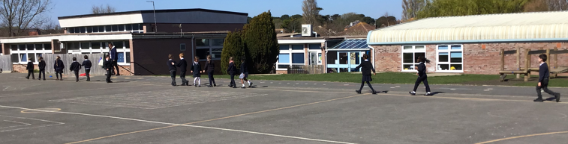

The aim of the walk is to get thousands of teams or individual walkers to join together, walking, fundraising and raising awareness of inequality across the world. Together means big change can happen. The money raised by taking part in the Big Lent Walk enables CAFOD to continue fighting global poverty and working through local partners to bring real life change to communities overseas. To find out more, please go to <https://walk.cafod.org.uk/>

On Monday we had a wonderful day led by volunteers from CAFOD (The Catholic Agency for Overseas Development.) They led a stimulating assembly linked to the jubilee year theme of Hope and then visited our Year 1-6 classes where children engaged in engaging workshops linked to Catholic Social Justice and with the thread of Hope for the world running throughout. We’re grateful to Bea and Heather for giving up their time to support us and they were so supportive of our Big Lent Walk that the children have been fully participating in throughout this Lenten season.

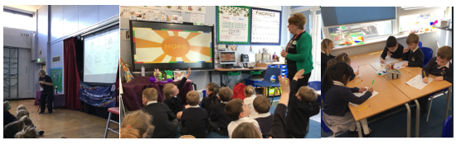

On Tuesday, our Reception Class led a lively and joyous Palm Sunday Service. It was so lovely to see our youngest children retelling the events of Jesus riding into Jerusalem with such enthusiasm.

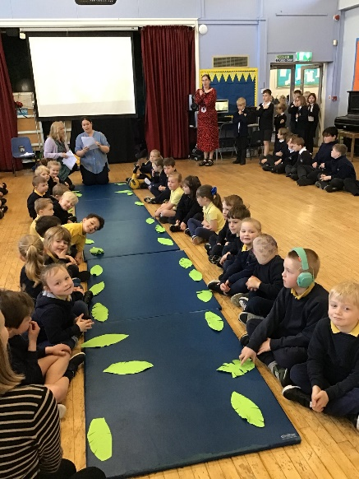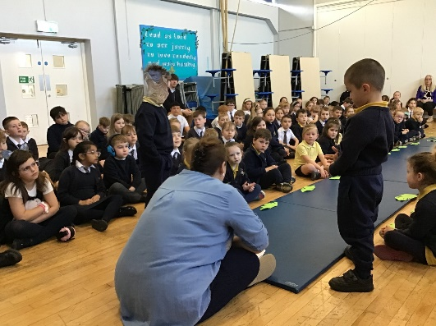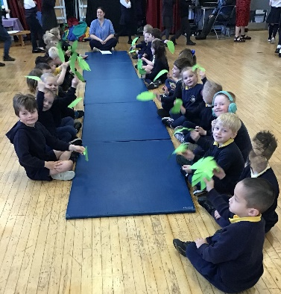

On Thursday, we held our annual Holy Thursday Service and enacted the washing of the feet to help our children understand the love and service that Jesus showed His disciples. We thank the Mini Vinnies and Father Anthony for leading this service and we also thank some of our Year 1 children for taking part.

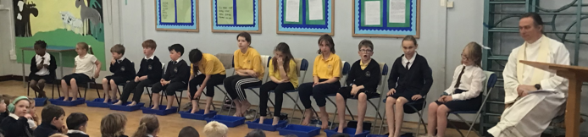

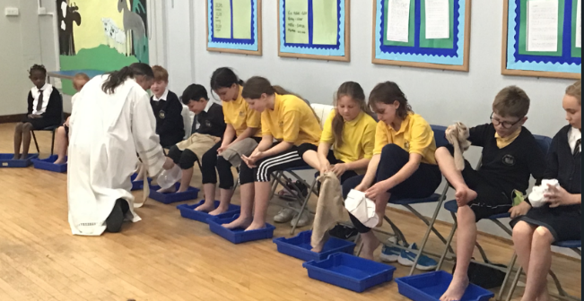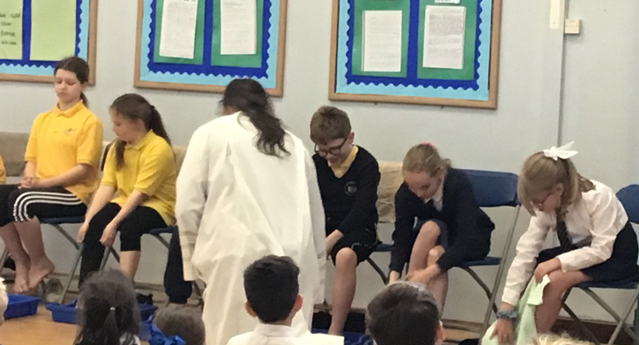

**Easter Mass Times : St. Joseph’s Church, Stavordale Road, Weymouth, DT4 0AB**

**Easter Mass Times @ St Joseph's Church**

**Maundy Thursday** – 17th April

7pm Evening Mass of the Lord’s Supper

**Good Friday** – 18th April

10am Children’s Stations of the Cross Rehearsal

**11am Children’s Stations of the Cross**

3pm The Passion of Our Lord Jesus Christ

**Holy Saturday** – 19th April

8pm The Easter Vigil

**Easter Sunday** – 20th April

8am Easter Sunday Mass

10am Easter Sunday Mass

**Precious Memories Gathering**

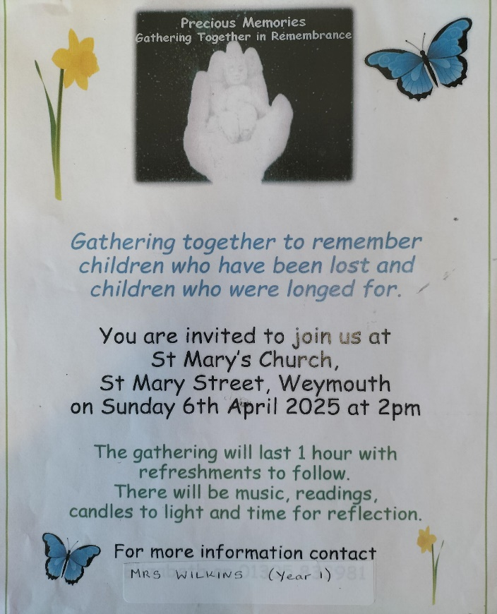

**Do you need support with Toilet Training your child?**



Please click on the link below for more information.

<https://eric.org.uk/all-aboard-the-toilet-train-get-ready-for-school/>

**Dorset Council have asked us to advertise the following sessions**

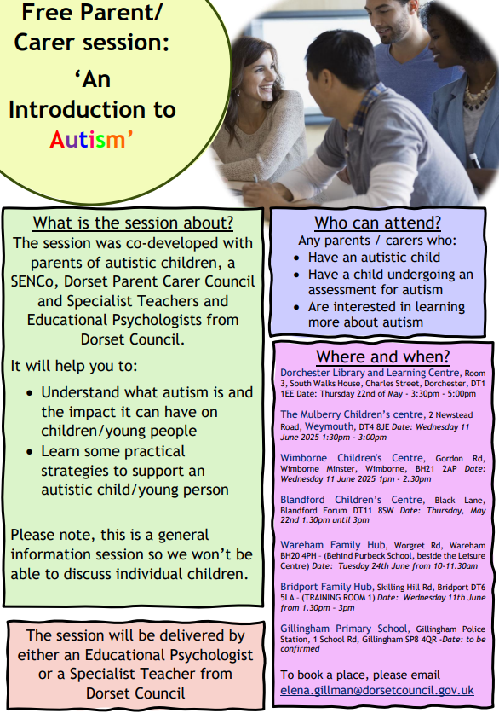

**School Crossing Patrol**

Please be reminded that currently there is no School Crossing Patrol in place on Chickerell Road. Please ensure your child takes extra care when crossing the road. Dorset Council are continuing to seek to recruit a new School Crossing Patrol. The School Crossing Patrol Duty Hours are: 8.20-9.05am and 3.10-3.35pm. If you are interested in the role or know someone that would be, please click on the following link for further information:

<https://www.dorsetcouncil.gov.uk/w/school-crossing-patrols>

Alternatively, please email [roadsafety@dorsetcouncil.gov.uk](mailto:roadsafety@dorsetcouncil.gov.uk) or call: 07747 180 741

**Sport News**

**Swimming Gala**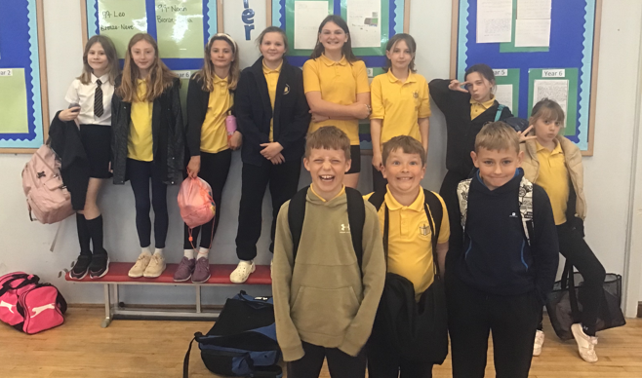

A team of swimmers, from Years 5 and 6 represented St Augustine’s at Weymouth Swimming Pool in the annual gala on Wednesday 2nd April. Each of them performed very well and were competitive in their races. Well done in particular to Julien, who won two of his races, and to the Year 5 girls, who won their relay. We look forward to competing again next year.

**Tennis** 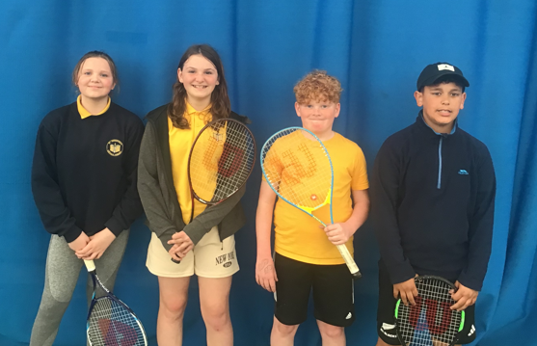

On Friday 28th March a team of four pupils from Year 6 represented St Augustine’s in a mixed tennis tournament at Wey Valley Tennis Centre. Both pairs played superbly, winning the majority of their matches in the league-style tournament. Overall, we managed to finish to second place- a fantastic achievement. Well done to all those involved.

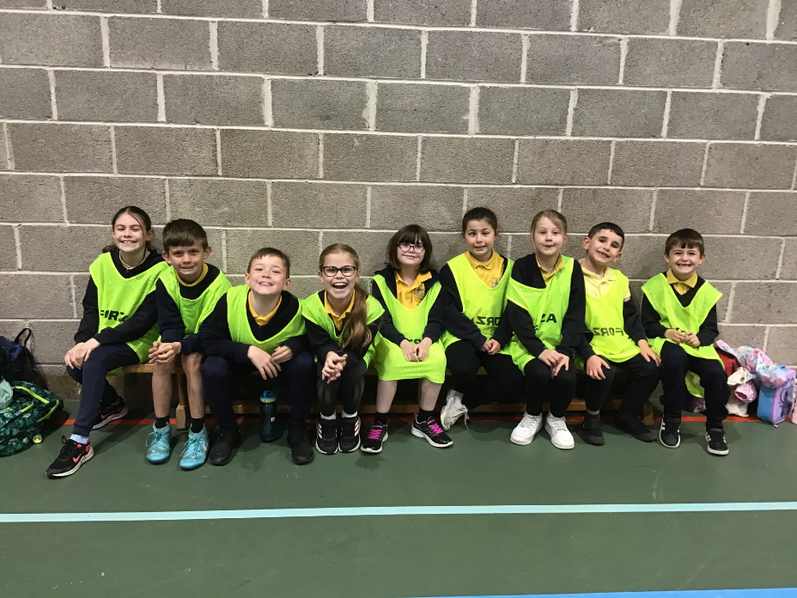**Handball**  On Tuesday 1st April, a group of 9 children from Years 3 and 4 attended a Handball Festival at Redlands. After some warm-up activities, they took part in four matches, with the twist being the lights were off! The florescent bibs enabled them to work together, and they managed to win two matches and were competitive in the two losses. They all thoroughly enjoyed their day- well-done to all involved.

**School Summer Uniform**

Please be reminded that children return to school wearing summer uniform after Easter Half term (i.e. from Tuesday, 22nd April 2025).

Full details of the uniform policy can be accessed via our website <https://www.staugustines.dorset.sch.uk/web/school_uniform/9950>

A selection of pre-loved summer uniform is available on the uniform rail in the school office foyer. Please feel free to drop in to browse through the rail. We ask for a donation of 50pm per item, which goes to FOSA.

Please remember to label all uniform with your child’s name.

|  |  |
| --- | --- |
| **Girls Summer Uniform**  Navy blue check dress, navy blue V-neck cardigan or jumper with school logo. Sensible black shoes or flat heeled sandals with straps (white or navy) and white socks. |  |
| **Boys Summer Uniform**  White polo shirt (short sleeved), charcoal grey trousers or shorts, navy blue V-neck jumper with school logo. Sensible black shoes or sensible black sandals and grey socks. |  |

**News from across the school**

|  |  |
| --- | --- |
| **Reception** | This final week we had some fantastic fun easter themed learning. Starting with creating 3D easter animals using egg cartons, painting eggs and handprinted chicks. In numeracy we had a week of consolidating all that the children have learnt in the past 6 weeks. Lots of focus on sentences in writing; using tools such as finger spacers, sound mats and picture prompts. We are very proud of the clear progress so many children are making in this area.  Our Palm Sunday service which Reception led in front of the whole school, was a big success. The children showed such confidence. The class also completed their soup making project in DT. They were able to cut the vegetables, name them, describe the smell and taste.  We hope you all have the loveliest Easter half term together, having some rest and play. |
| **Year 1** | It’s been a great end to our term. The Year 1 children have been busy wrapping up their foundation subject topics and had fun in Computing this week as they completed work on algorithms by following sequencing instructions that they followed to make a junk model rocket. We were so delighted with the children’s understanding of sequence.  In RE the children have continued to journey through their topic on Lent and have shown sensitivity in considering the feelings of Jesus and His disciples at different points in the Easter story. In Geography the children have now finished work on learning about urban, coastal and rural areas and have shown a good understanding of geographical terms.  Happy easter from Year 1. |
| **Year 2** | We have had a great week in Year 2 to finish off a very busy Spring Term. To begin the week, the children finished making their paper, 3D chairs for Baby Bear as part of their DT project - we definitely have some keen designers in the making! In our Geography lesson this week, the class explored what we might see, hear, smell, touch and taste when visiting a hot or cold desert. In English this week, Year 2 have planned and written some excellent instructions for making some VERY silly sandwiches! They did an excellent job at laying out their instructions with a diagram, list of ingredients and writing clear steps. However, we're not sure we would be ordering any of these sandwiches at a café anytime soon!  This week, children have been sent home with their sponsorship forms for their sponsored scavenger hunt, which will take place after the Easter break. We would greatly appreciate any help with children collecting their sponsors over the half-term. Thank you.  To finish off the Spring Term, the class celebrated all their hard work with a Pasta Party on Friday afternoon. They all thoroughly enjoyed bringing in some of their favourite cuddly toys and watching a movie whilst eating a tasty snack! Well done for all your hard work this term Year 2. We hope you have a lovely Easter break. |
| **Year 3** | We have had a busy week again in school. We have finished the second book of our power maths. We finished with a unit about capacity using litres and millilitres. In English, the children have written their own newspaper articles based on our whole class reading text, The Iron Man. We answered our enquiry question in Geography this week which was: would you like to live near a volcano and why? The children came up with great answers and reasons! We have spent lots of time in RE learning about the Eucharist and to finish the learning branch this week, we thought about what the words mean at the end of a mass and how we can go into the world and spread the word of the Eucharist. The children finished some lovely art work inspired by pointillism this week. |
| **Year 4** | We’ve had a lovely week in Year 4 to end our spring term. On Wednesday, we went to Radipole Nature Reserve and we were very lucky to be introduced to the importance of reserves by Carla from the RSPB. We went for a long walk around the reserve looking out for all the different bird species that live here.  In our English this week, the children finished off their poetry unit by writing their own nonsense poems inspired by the Jabberwocky. There are some really brilliant pieces of writing that have been produced.  On Thursday afternoon, they put their French into action by ordering ice creams from Monsieur Edmonds’ ice cream stall. Every child in the class was able to order an ice cream in French successfully- so make sure you take them along when you’re next off to France!  During the holidays, there is a TTRS tournament running Y3 vs Y4. It would be fantastic to see every child participating in this. Our home learning expectations are that children spend at least 20mins per week practicing their multiplication.  **Reminder** after the holidays, Y4 children only need to come to school in PE kit on Mondays. Our second PE slot will be taken by swimming on Wednesday mornings. Please send your child to school on **all Wednesdays in Spring 1** with a swimming kit containing a towel, swimming hat, swimming costume and goggles. Please ensure these items and their uniform are named.  Have a great Easter break |
| **Year 5** | We come to the end of our second school term with more of our Year 5 journey covered than there is to come. So, as we look back at all that we have achieved since September we also look forward with anticipation to the Summer Term, warmer weather and all that is to come. We have covered so much and the assessments that the children sat this half term just go to prove this. The evidence in books and what we see every day in class let us know that all children are making progress and this is incredibly pleasing. With renewed effort after the Easter break then we are sure that the children will be ready for Year 6 and all that entails. As ever, thank you for your continued support, it really makes a difference, but should there be any issues then please do not hesitate to get in touch. We will see you all on Tuesday 22nd April. Enjoy the break. |
| **Year 6** | Another busy week in our final week this term. The children have worked very hard to continue their teddy jackets in D.T- some of this may need to be completed after Easter- and have enjoyed investigating the different effect certain conditions have on bread. In Maths, we completed our work on area and shape, while in Reading we have started our new class text. While it is a completely different style from some that have come before, it has already encouraged discussion and is introducing us to some high-level vocabulary.  Thank-you for your support over what has been a very busy term. When we return, there will be a fair amount of revision incorporated into our learning. We will ensure that there is no pressure however and that it continues to be an enjoyable learning environment. Have a lovely, restful, Easter break and we will see you back for the Summer Term. |
| **News from Breakfast Club** | In breakfast club, we noticed that the Cornflakes were not being eaten. So that they didn’t go to waste, the children turned them into chocolate crispie cakes. We melted chocolate and mixed the cornflakes in, we put the mixture into cake cases and put a chocolate egg on top.  We were lucky enough to eat one at lunchtime and then take some home. |

**Useful Dates**

|  |  |
| --- | --- |
| Mon 7th April to Mon 21st April | Easter holiday |
| Tue 22nd April | Children back to school |
| Wednesday, 30th April | Year 5 Class Assembly at 2.40pm |
| Thursday 1st May | 8.30 - 10 am Jules Arscott (Early Help Link Worker) Drop in session |
| Mon 5th May | Bank Holiday |
| Wednesday, 7th May | Year 3 Class Assembly at 2.40pm |
| Thursday, 8th May | Year 3 trip to Dorchester Museum and Roman Town House |
| Wb Monday 12th May | Year 6 SATS week |
| Wednesday, 21st May | Year 6 Class Assembly at 2.40pm |
| Mon 26th May to Fri 30th May | Half Term Holiday |
| Mon 2nd June | Training Day – no children in school |
| Thursday 5th June | 8.30 - 10 am Jules Arscott (Early Help Link Worker) Drop in session |
| Wednesday, 11th June | Reception Class Assembly at 2.40pm |
| Wednesday, 2nd July | Year 2 Class Assembly at 2.40pm |
| Wednesday, 2nd July to Friday, 4th July | Y6 Residential – PGL Barton Hall |
| Thursday 3rd July | 8.30 - 10 am Jules Arscott (Early Help Link Worker) Drop in session |
| Wednesday 9th July – Friday 11th July | Y6 Primary College |
| Wed 16th – Fri 18th July | Year 4 Residential – Minstead Study Centre |
| Tues 22nd July | School Closes 3.15pm |
| Wed 23rd July | Training Day – No children in school |

**Masses and Liturgical Events 2024-25**

**All masses to take place at 9.30am in the hall at school**

Please be aware when your child’s class is leading a Mass, you are very welcome to attend. Please come to the office 5 minutes before the Mass is due to start.

|  |  |
| --- | --- |
| Summer Term | |
| Thursday 24th April | Whole School Easter Mass  9.30-Year 4 to lead |
| Thursday 22nd May | Mary Procession  2.15-Mini Vinnies |
| Thursday 12th June | Whole School Pentecost Mass  9.30-Year 5 to lead |
| Thursday 26th June | Whole School St. Peter and St. Paul and  First Holy Communion Celebration Mass  9.30-Year 3 to lead |
| Thursday 17th July | Leavers’ Mass  9.30-Year 6 to lead |