Issue 25   25th April 2025



**This week**

Welcome back everyone from the Easter holidays. It’s great to see the children returning to school in their summer uniform. All of the children have come back to school looking well rested and with a spring in their step! We look forward to another busy half term, with new units being launched in the curriculum. Reception and Year 2 have been fundraising for, “School in a Bag” and we look forward to seeing how much we have raised for the charity in the coming weeks and we will keep you posted. Year 3 will be baking and selling cakes after school on Wednesday 30th April to raise money for the charity, so please bring some pennies if you’d like to support their fundraising efforts.

**Catholic Life**



This week, following the sad news of the Pope’s death, we took time to pray for him as a worshipping community during our Celebration of the Word.

It was a special time and some of our children and staff chose to visit the chapel at playtime on Tuesday to spend more time in prayer and to think about those they have loved who have died.

On Thursday, we had a reflective Easter Mass which was led by our Year 4 class. The children led the readings and prayers and the whole school sang beautifully. We thank Father Anthony and Mrs Ayles for their commitment in supporting us in our spiritual life at school.

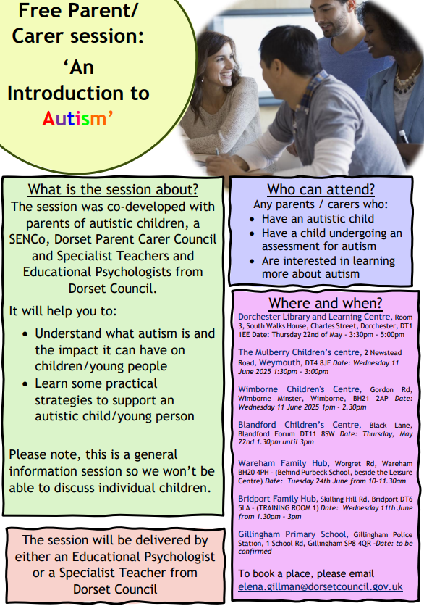

**School Crossing Patrol**

Please be reminded that currently there is no School Crossing Patrol in place on Chickerell Road. Please ensure your child takes extra care when crossing the road. Dorset Council are continuing to seek to recruit a new School Crossing Patrol. The School Crossing Patrol Duty Hours are: 8.20-9.05am and 3.10-3.35pm. If you are interested in the role or know someone that would be, please click on the following link for further information:

<https://www.dorsetcouncil.gov.uk/w/school-crossing-patrols>

Alternatively, please email [roadsafety@dorsetcouncil.gov.uk](mailto:roadsafety@dorsetcouncil.gov.uk) or call: 07747 180 741

**News from across the school**

|  |  |
| --- | --- |
| **Reception** | Welcome back, we hope you all had a lovely Easter Break. Reception have had a fantastic start to the Summer Term, returning to a very special delivery of our chick eggs! Most have hatched already, it has created a lovely buzz in the classroom. Not only are we holding great descriptive conversations, but we are all getting to see change, growth and life cycles happen in front of our eyes! The children have been using number tracks and hopscotch to practice counting on in Numeracy. In literacy the children have been writing descriptive sentences about the Hungry Caterpillar. In DT we have moved onto textiles; discovering more about creating art with fabric and weaving techniques. Finally, in RE we marked the incredibly sad passing of Pope Francis with special prayers and discussed in more depth Ascension and what Heaven may look like. Then in our new Understanding the World topics we have begun to think about how others celebrate special occasions and how our homes have changed over time. |
| **Year 1** | It’s been a good start to the Summer Term. The children have been learning about the events of Eastertide in RE and have loved learning some lively new worship songs. In English we’re starting a unit on story writing linked to journeys. We’re using the story of ‘The Smartest Giant in Town’ by Julia Donaldson to stimulate our ideas. Over the coming weeks we’ll be retelling and modifying the story to include our own journey ideas and will be introducing our own settings and characters. In Maths we’re working on Multiplication, and we’ve been very impressed with the children’s skills in counting in 2s, 5s and 10s. We’re looking forward to new learning in the foundation subjects and will inform you of the exciting learning taking place over the coming weeks. |
| **Year 2** | Year 2 have had an excellent week back after the Easter holidays. This week in English we have been thinking carefully about how to make the start of our sentences more interesting, ready for writing our own short story in the next few weeks. In our Maths lessons, we have continued to learn all about measurement, focusing more on how we can measure liquids in millilitres and litres. We have also been exploring how to measure temperature using a thermometer. This half term in History, we are learning all about the great explorers, Christopher Columbus and Neil Armstrong. We began the topic by finding out all about why people remember them and what they were famous for exploring.  On Wednesday, the children completed their Sponsored Scavenger Hunt to raise money for the charity “School In a Bag.” The children had a great time completing the hunt! We are thrilled to hear about all the sponsorship that children have gathered. Please can we ask that sponsorship money comes into school next week to the class teacher. We will keep you updated about how much we have raised for the charity! Thank you so much in advance for all your support! |
| **Year 3** | Welcome back! We have had a busy but good first week of summer one. We have finished our text in whole class reading. We really enjoyed reading the Iron Man. In Maths, we have been adding and subtracting fractions. We have started learning about Roman Britain in History and looking at why Claudius decided to try and conquer Britain when Julius had failed. We have started topic about food in DT. The unit is called eating seasonally and we are going to be looking at different fruits and veg that are grown in Spring and then using them to make tarts at the end of the unit. In RE we have been learning about the Road to Emmaus and thinking about how the disciples felt.  PLEASE NOTE: we have moved our class assembly to Wednesday 14th May so that we can share pictures and learning from our trip! |
| **Year 4** | This first week back has felt a bit like a whirlwind! Thank you to those who were able to attend our mass on Thursday, I think you will agree that it was a mass that was beautifully presented by Year 4 and I was very proud of them. We went for our first swimming session on Wednesday and I was particularly impressed with how well the children conducted themselves, we have some very capable swimmers in the group but even those who are less confident impressed me greatly with their tenacity. In our learning, we have begun thinking about food chains and food webs in science which will lead us into thinking about the digestive system. Our maths learning is still focused around decimals. In English we are thinking about diaries and journals. |
| **Year 5** | We hope you had a good Easter and it has been pleasing to see how the children have returned to school with a positive attitude and willingness to learn. We were lucky enough to take part in a Year 4 led Mass this week, where not only did we get to reflect on the Easter message and the resurrection of Jesus, but also spend some time thinking about the late Pope and the part he played in enriching our lives through his words and actions. Looking forward we have a short though action packed half term ahead of us. We are currently finalising details of our class trip to the Nothe Fort (this ties in perfectly with a great deal of our learning coming up) and will provide you with all necessary information as soon as we have everything confirmed. The children are currently constructing facsimile gas mask cases in Art and with this letter you should find some examples of evacuee costumes; something that the children might like to copy when we go on our trip. Again though, further details will be provided as soon as we have them. |
| **Year 6** | A wonderful first week back, and one in which everyone can be very proud. We hit the ground running, and the children have risen to the challenge of going that extra mile for the next few weeks. We have focused on revising some key knowledge and skills and will continue to work on this. In Maths, we have had a real look at multiplying whole numbers with mixed numbers, while we also revisited time and looked at some reasoning questions around this.  In R.E, we thought about what it meant to be a witness and how this could be both a positive and a negative. We thought about this in a Christian sense and also related it to situations in life that we have experienced.  In English, we did some work around instruction writing, we look forward to building towards a larger piece of creative writing around this.  We enjoyed an assembly from the RNLI on Thursday and, certainly, will listen and follow their advice when it comes to swimming in the sea. |

**Useful Dates**

|  |  |
| --- | --- |
| Wednesday, 30th April | Year 5 Class Assembly at 2.40pm |
| Thursday 1st May | 8.30 - 10 am Jules Arscott (Early Help Link Worker) Drop in session |
| Mon 5th May | Bank Holiday |
| Thursday, 8th May | Year 3 trip to Dorchester Museum and Roman Town House |
| Wb Monday 12th May | Year 6 SATS week |
| Wednesday, 14th May | Year 3 Class Assembly at 2:40pm |
| Wednesday, 21st May | Year 6 Class Assembly at 2.40pm |
| Mon 26th May to Fri 30th May | Half Term Holiday |
| Mon 2nd June | Training Day – no children in school |
| Thursday 5th June | 8.30 - 10 am Jules Arscott (Early Help Link Worker) Drop in session |
| Wednesday, 11th June | Reception Class Assembly at 2.40pm |
| Wednesday, 2nd July | Year 2 Class Assembly at 2.40pm |
| Wednesday, 2nd July to Friday, 4th July | Y6 Residential – PGL Barton Hall |
| Thursday 3rd July | 8.30 - 10 am Jules Arscott (Early Help Link Worker) Drop in session |
| Wednesday 9th July – Friday 11th July | Y6 Primary College |
| Wed 16th – Fri 18th July | Year 4 Residential – Minstead Study Centre |
| Tues 22nd July | School Closes 3.15pm |
| Wed 23rd July | Training Day – No children in school |

**Masses and Liturgical Events 2024-25**

**All masses to take place at 9.30am in the hall at school**

Please be aware when your child’s class is leading a Mass, you are very welcome to attend. Please come to the office 5 minutes before the Mass is due to start.

|  |  |
| --- | --- |
| Summer Term | |
| Thursday 22nd May | Mary Procession  2.15-Mini Vinnies |
| Thursday 12th June | Whole School Pentecost Mass  9.30-Year 5 to lead |
| Thursday 26th June | Whole School St. Peter and St. Paul and  First Holy Communion Celebration Mass  9.30-Year 3 to lead |
| Thursday 17th July | Leavers’ Mass  9.30-Year 6 to lead |