Prayer and Worship
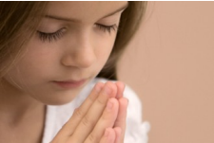
At St. Augustine’s School, Worship is important in helping develop our faith. Our children and staff have opportunities to worship on a daily basis

Class Worship and Voluntary Prayer
Every day, each class says 3 prayers.
Our Morning
Prayer Father in Heaven,
We give you today,
all that we think and do and say.
Please be with us and help us today,
to please you Lord in every way. Amen.

Our Lunchtime Prayer
Thank you for the world so sweet.
Thank you for the food we eat.
Thank you for the birds that sing.
Thank you God for everything.
Amen

Our End of the Day Prayer
Now the day is over,
we lift our hands and say
Thank you Heavenly Father for today.
We’re sorry for the wrong things,
But glad about the right. Keep us Heaven Father,
in your love tonight. Amen.


After lunch every day, each class takes part in Christian meditation. The act of quiet prayer allows our children to be still in the presence of the Lord and allows them to make time for Christ and in doing so, to be be calm and contemplative. Every class has a weekly chapel time, when they use the school chapel for class worship activities.
Opportunities for voluntary prayer are encouraged and some children choose to record their prayers in prayer journals. Other opportunities for voluntary prayer are provided with children writing prayers at our prayer stations and also asking to pray alone or with their classes in the course of the day.
Our chaplain, Deacon Geoffrey also prays with any child or group who would like to pray.

Collective Worship at St Augustine’s
Monday morning Liturgies
Our Monday morning Liturgies, start our week with a focus on the Gospel reading from the prior Sunday. Children write and lead the prayers of intercession and within this act of worship, Gospel Values and Laudato Si become an integral part. Children leave the hall with a thought for the week and a prayer focus to stimulate prayers and discussions back in the classroom.

Sing and Praise
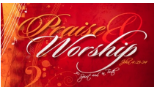
This act of worship takes place once a week and starts with our school mission statement prayer and this is followed by the Our Father. The children take part in singing worship songs and hymns and then during this act of worship, children read prayers they have written. We also pray the Hail Mary and the Glory be prayers.

Class Masses and Whole School Masses
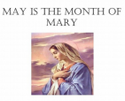
On a monthly basis, Father Stephen, our parish priest comes into school to celebrate class masses and whole school masses. He is accompanied by Deacon Geoffrey, our school chaplain. Class masses take place for one class and their families in our school chapel. Whole school masses take place in the hall and all our parents are invited. During the masses, children lead readings, prayers, the offertory procession and singing and at whole school masses, some of the children accompany the singing by playing a range of instruments.

Other Liturgical Celebrations
At St. Augustine’s School we plan for other liturgical events. During Advent, we dim the lights in the hall and have daily advent reflections. During Lent, we focus on a charitable organization to help and make it our Lenten mission to do good for others. In May, we often have a procession and special liturgy for Mary, the Mother of Jesus and when we are at school On All Saint’s Day and Ash Wednesday, we also have special extra whole school liturgies/services.

