
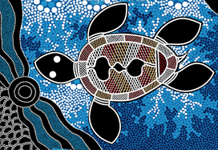

ICT

Coding (Mr Tuson)
Skills focus:
- Understand what algorithms are.
- Predict the behaviour of simple programs.
Using computers
Skills focus:
- Use technology purposefully to create digital content.
Online Safety
Skills focus:
- Understand what is meant by personal information and how we can protect it.
- Recognise that anyone online who we don’t know in real life is a stranger.

ART AND DESIGN

Skills focus:

- Explore mark making using a variety of tools including pencils, pastels, crayons, paint and cotton buds.
- Cut, glue and trim materials to create images.

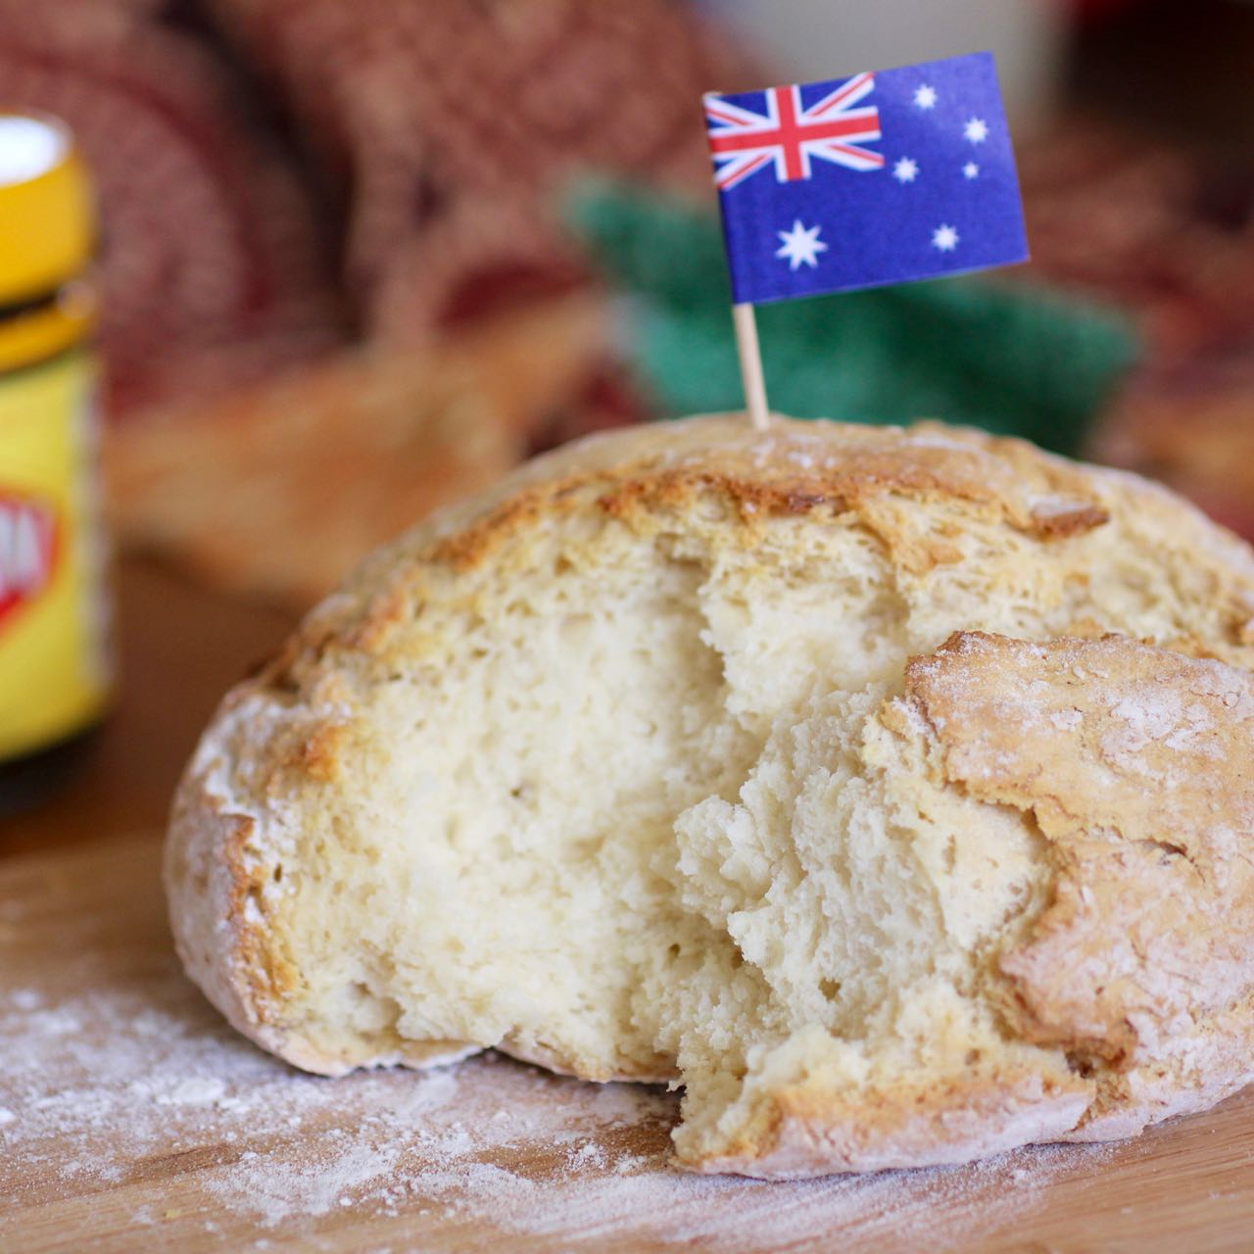
D.T

Skills focus:
- Use simple tools to prepare food safely.
- Say where food comes from.

YEAR 1 SPRING 2 – AUSTRALIA



MUSIC (Singing with Mrs Ayles)
Skills focus:
- Listen to and copy a simple rhythm and melody.


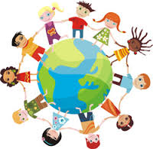
PSHE
Getting On and Falling Out.
Skills focus:
- Managing feelings.
- Recognise how actions affect other people.
- Listen to others and play and work cooperatively.

Going for Goals.
Skills focus:
- Children reflect on themselves as individuals.
- Identifying own strengths.
- Taking responsibility and building confidence.



PE
Gymnastics.

Skills focus:
• Describe and comment on performance.
• Create sequences of actions and skills.

MUSIC (Mrs Ayles)
- Recorders

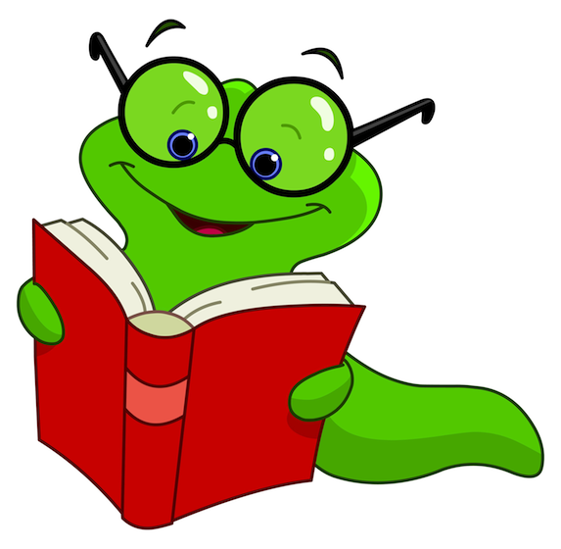
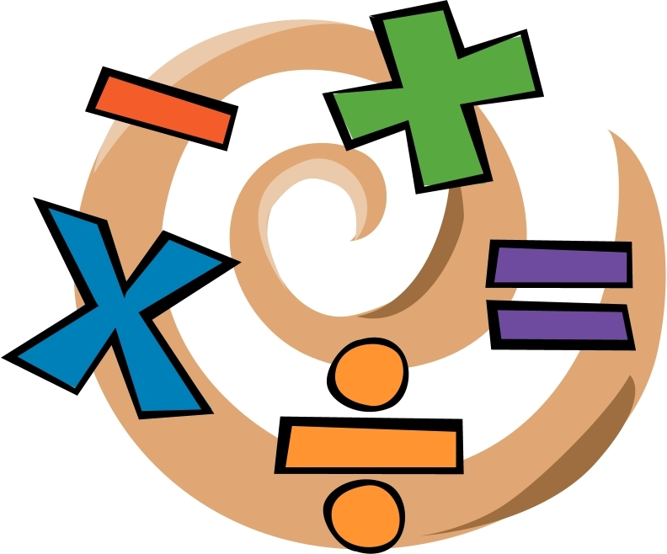
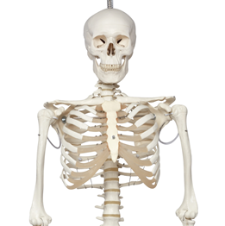

SCIENCE

Topic context: Animals

including humans.

Skills focus:
- Identify animals that are carnivores, herbivores and omnivores.
- Identify, name, draw and label the basic parts of the human body and say which part of the body is associated with each sense.

ENGLISH

WORD READING FOCUS
- Say the sound of all the letters and letter groups.
- Use letter sounds to work out and read new words.
- Read some common exception words and see where the letter sounds are different.

COMPREHENSION FOCUS
- Take part in discussions about what is read to him/her, taking turns and listening to what others say.
- Explain clearly his/her understanding of what is read to him/her.
- Say how the characters in a story might feel on the basis of what is said and done

WRITING
- Write sentences by saying out loud what they are going to write about.
- Read sentences and check that they make sense.
- Join sentences together to make a story.
- Use capital letters and full stops to mark sentences.
- Use spaces between words.
- Use verbs and adjectives.

HANDWRITING
- Sit correctly at a table, holding a pencil comfortably and correctly.
- Form lower-case letters in the correct direction, starting and finishing in the right place.
- Form capital letters.
- Form digits 0-9
- Understand which letters belong to which handwriting families.

SPAG
- Spell words containing each of the letter sounds taught.
- Spell common exception words
- Name the letters of the alphabet in order.
- Add s or es to words to make them plurals e.g. dog, dogs; wish, wishes.
- Use suffixes ed, er, ing

CLASS TEXT
- ‘How Kangaroos got their Tails’ and
other Aboriginal Dreamtime stories.
MATHS
NUMBER AND PLACE VALUE
- Counting in tens and ones.
- Comparing numbers within 40.
- Finding more or less than a given number within 40.
- Making number patterns within 40.

ADDITION AND SUBTRACTION.
- Represent and use number bonds within 20.
- Represent and use subtraction facts within 20.
- Write mathematical statements involving addition (+), subtraction (-) and equals (=) signs
- Solve one-step problems that involve addition, subtraction and missing numbers using concrete objects and pictorial representations.

YEAR 1 SPRING 2 – AUSTRALIA



RE

Lent
Skills focus:
- Recognise some of the signs and symbols used in an Ash Wednesday service.
- Understand why Jesus went into the wilderness.
- Describe scripture in their own words.
- Recognise some ways of praying.
- Talk about how prayer makes you feel.
- Understand that prayer is a way of getting closer to God.

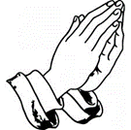

GEOGRAPHY
Skills focus:
• Use simple maps.
• Use observational skills to describe
landscape.
- Ask geographical questions such as ‘What is it like to live there?’

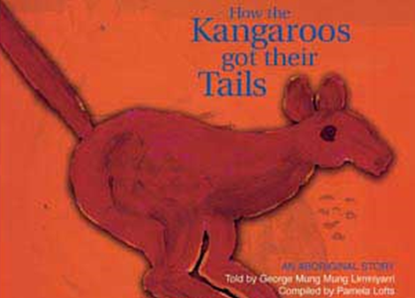
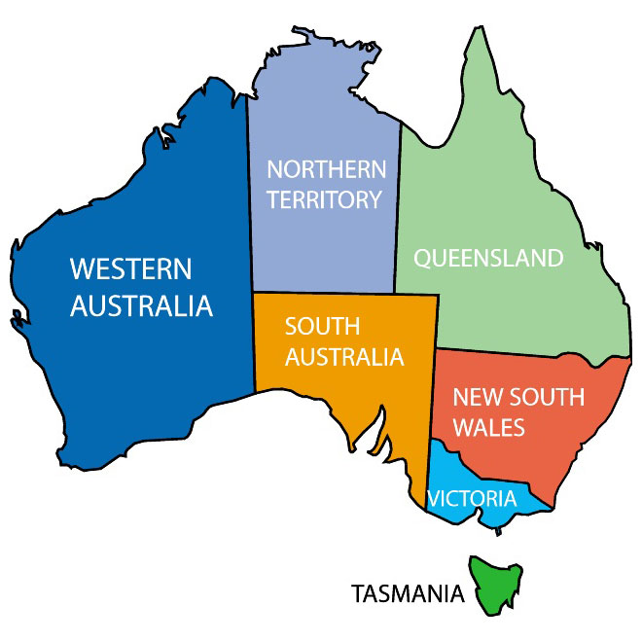

HISTORY

Skills focus:
- Understand key features of events.
- Find answers to questions
using sources of information.
- Talk, draw or write about the past.





