Parents in
Partnership
YEAR 5
Homework: Autumn 1 Week 7

My child’s response to the tasks.
MATHS

This week the children have consolidated calculating fractions of quantities and continued to create, read and interpret data.

Homework – complete the two-way tables and answer accompanying questions.

ENGLISH

The children have continued to write persuasively and to write descriptively within their narratives. Within both genres and in the starter activities, word classes have been looked at.
Homework – Create expanded noun phrases and preposition of place.

Spellings – The children have 5 key words and 5 words with the long vowel sound i spelt with y to learn for a test on Thursday.

READING CHALLENGE
The Reading Challenge will begin after half term. When children have read 30 times at home, this will be celebrated in each Friday’s assembly. They will receive a certificate and badge to acknowledge their achievement. Different badges can then be earned as more reading milestones are achieved.

SCHOOL COUNCIL
After half term, members of the school council will be elected. Those interested in being part of the school council will need to prepare a speech outlining why they should be elected. Speeches will be heard on Tuesday 5th November and voting will take place on Wednesday 6th November.
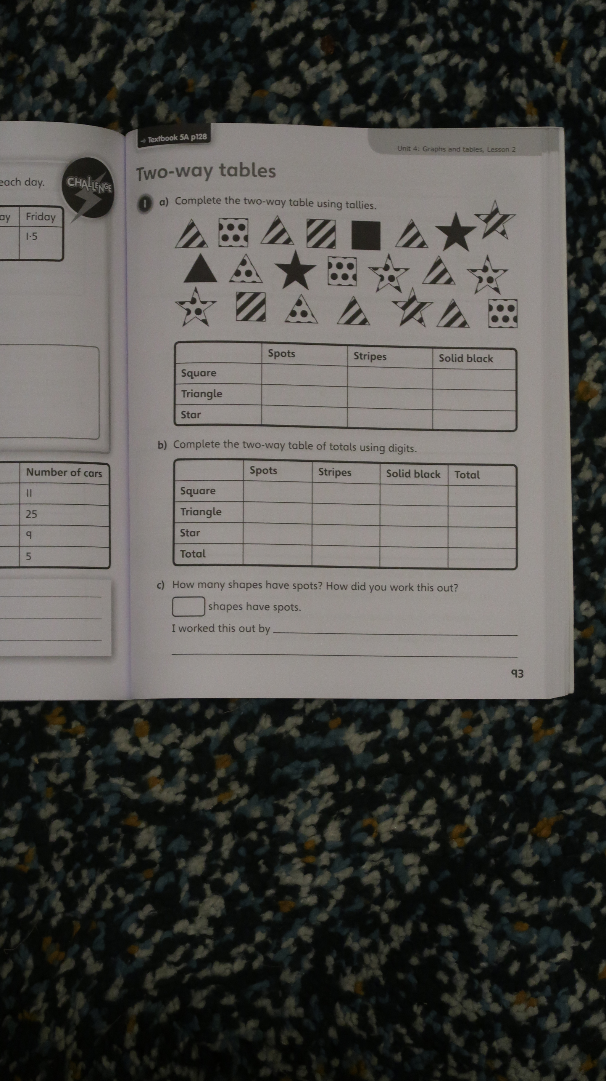

The two-way table shows how many children from one class travel to school.

 | Walk | Cycle | Car | Other | Total
Boys | 7 | 3 |  | 1
Girls |  | 1 |  | 0
Total

- There are 27 children in the class.
- There are 15 boys in the class.
- 7 children travel by car.

- Use the information to complete the two-way table.

- How many more children walk to school than cycle to school?

- “More than half of the children walk to school.”
Is this statement correct?

Explain how you know.



