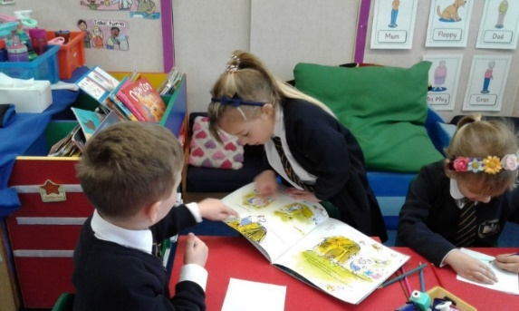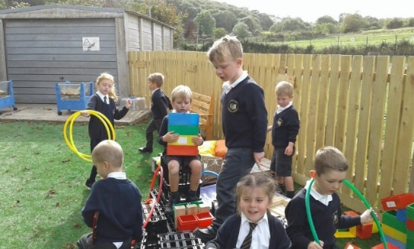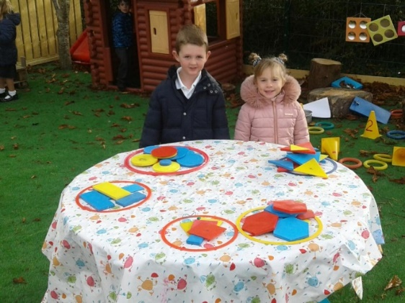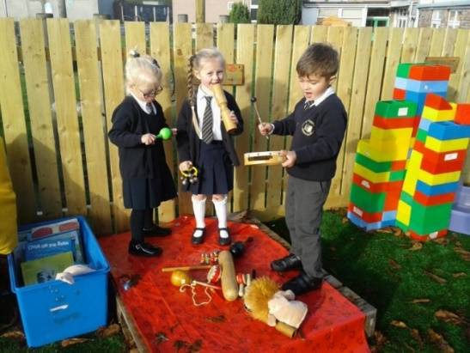

Personal, Health and Social Education at Foundation Stage (Reception) forms one of the Prime areas of the EYFS Curriculum and is taught through Personal, Social and Emotional Development. It also permeates through the Characteristics of Effective Learning which are ‘Playing and Exploring,’ ’Active Learning’ and ‘Creating and Thinking Critically.’ Relationships and Health Education is also part of Personal, Social and Emotional Development, but is also taught in close connection with RE.

PHSE and RHE are very important subjects in all stages of a child’s education. From the moment a child starts school they learn to self-regulate, manage themselves and build relationships. These are the 3 areas of Personal, Social and Emotional Development that our work in reception focuses on.

Children are taught our Gospel Values. These are the behaviours and qualities that we encourage our children to display and these are: Compassion, Forgiveness, Justice, Integrity, Kindness Courage, Humility and Peace. These, together with our ‘Good to Be Green’ behaviour scheme, help our children understand the importance of caring for one another and help us teach them all about our expectations for behaviour. To read more on this subject, please go to the Behaviour Policy which can be found in the Policies section of our school website.

We use resources from the Coram Scarf PSHE Scheme and from the Ten Ten ‘Life to the Full’ Scheme for teaching Relationships and Health Education in line with all other Plymouth CAST Schools. These schemes provide discrete lessons that are designed for Reception aged children and are built upon progressively through their time at St. Augustine’s School, ensuring that concepts are introduced and explored gradually and appropriately. Both the schemes also teach key vocabulary and in this way, help the children develop their emotional literacy and ability to understand and communicate their needs and opinions.

As well as having structured lessons on a regular basis, throughout the children’s school day, there are opportunities for us as practitioners to help them develop personally, socially and emotionally. We use every encounter that we have with the children as a learning opportunity to help them thrive as valued individuals. Children are taught to express their feelings, show resilience in the face of challenge and to identify and moderate their feelings socially and emotionally. Children learn ways to manage their own hygiene and the importance of making healthy food choices. When learning about building relationships, children learn to work and play cooperatively with others and to show sensitivity and understanding of others building up their ability to feel a member of a group.

Through ‘Playing and Exploring,’ ’Active Learning’ and ‘Creating and Thinking Critically,’ children develop so much through the reception year and the foundation skills they learn in Reception prepare them for their next stage of learning in Year 1.

Developing self-awareness and working as a team to complete a task.

Making relationships and cooperating as children share a book.

Cooperating to make a pirate ship in role play.

Personal, Social and Health Education and Relationships and Health Education in the Early Years

Working collaboratively to make music in a band.