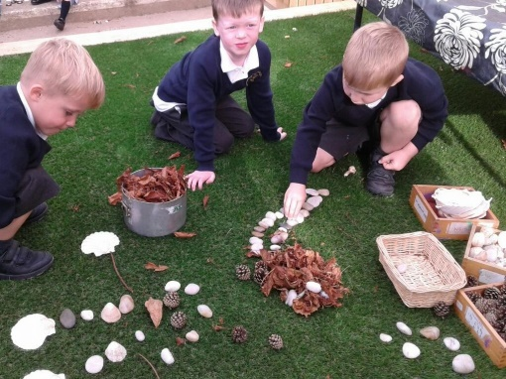

RE at Foundation Stage (Reception) is covered in the ‘Understanding the World’ area of the EYFS Curriculum.

‘Lead Us Lord, To Act Justly, to Love Tenderly and To Walk Humbly. Amen’ This is our School Mission Statement Prayer and when our children start school we teach them that God made us and our wonderful world and that we should care for each other and the world as God wants us to.

Our first topic in Reception is ‘Marvellous Me’ and it allows us to teach the children all about God’s creation and how precious life is. This emphasis on care for ourselves, one another and God’s world comes from Pope Francis’ letter to the people of the world called Laudato Si, and it is from his teachings that we base our curriculum.

We teach from the Come and See RE Scheme and the themes we cover are the same as those in the rest of the school and follow the Liturgical year. For more information regarding the RE Curriculum and Assessment in RE, please read the RE Curriculum and Assessment at St. Augustine’s document under the RE tab of the curriculum area of the school website.

Children are taught RE every day in Reception and the lessons take many forms. The children sometimes listen and respond to scripture through discussion, drawing or drama. They also learn how we can use God’s teaching in living our lives. They learn about the importance of prayer and pray 3 times a day, in the morning, before lunch and at the end of the day. To develop their spirituality, the children sometimes help to compose class prayers and time is given to independent reflection on a daily basis in line with the rest of the school. We spend time teaching the children that it’s important to be at one with the Lord and this precious time allows the children to spend part of their day being at one with Christ. The children are taught about awe and wonder and to consider the beauty of the world we live in.

Children are taught our Gospel Values. These are the behaviours and qualities that we encourage our children to display and these are: Compassion, Forgiveness, Justice, Integrity, Kindness Courage, Humility and Peace and we are proud to have embedded these fully as a school wide worshipping community, placing Christ and these values at the centre of our work. We also teach the Catholic Virtues, the habitual behaviours by which we live out our faith.

In the course of the children’s self-initiated activities, the indoor and outdoor environments are set up to help the children learn through play. When a child starts an RE based activity, adults work hard to develop their knowledge and understanding and their ability to communicate their feelings and spirituality.

All of our RE work together with the time we spend on teaching our children about Catholic Life, help them progress seamlessly into Year 1 where they continue their spiritual journey.

RE in the Early Years

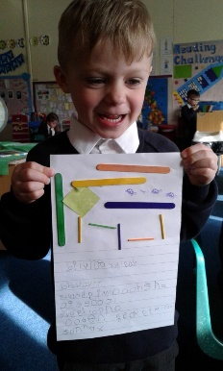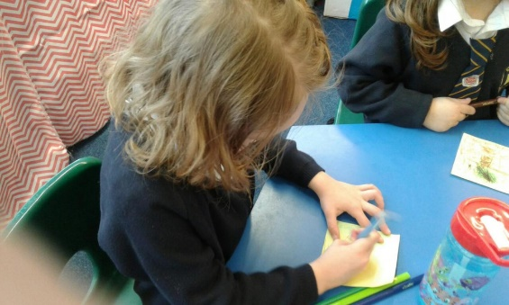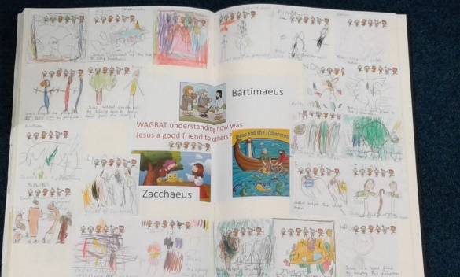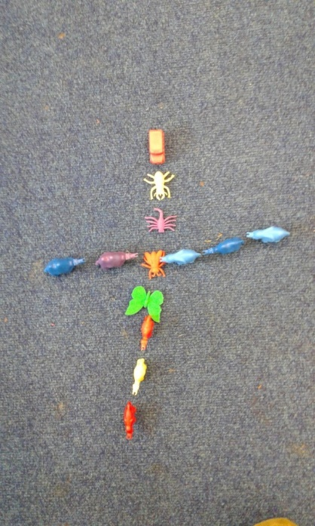

Choosing to write a prayer to Jesus.

Children using natural materials to make a picture of God’s world.

Drawing a picture to show how Jesus is special.

Using found objects to create a cross of thanks for God.

The children’s work on how Jesus helped Zacchaeus and Bartimaeus in our class RE Book.

Creating a Dragon Dance as part of our work on Chinese New Year in the ‘Take a Trip Around the World’ topic.