The RE Curriculum and Assessment at St. Augustine’s School
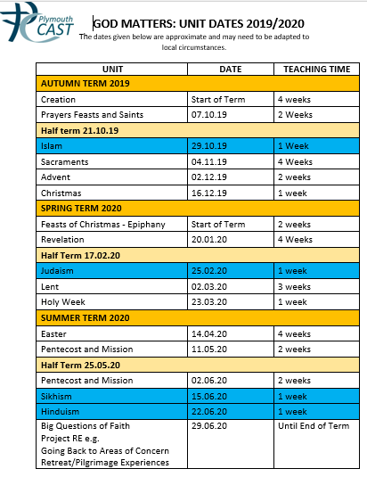
As a Plymouth CAST School, we follow the God Matters scheme to teach RE. The scheme covers 10 themes throughout the year, guided by the Liturgical calendar. Once a term, we also teach about another world faith. Each topic explores Scripture, our response to its teachings and Church tradition. Through their work the children develop their knowledge and understanding,

The children develop their skills in RE by:
Learning about RE – Knowledge and Understanding-AT1
Learning from RE-Engagement and Response-AT2
From Year 3 upwards- Analysis and Evaluation-AT3

Assessment of RE
Assessment in RE Teachers carry out ongoing assessments of the children in RE.
The children are assessed using the Standards for RE which are arranged in age bands, 3-5, 5-7,7-9,9-11.
Parents are informed of their children’s progress in RE at Termly Parent/Child/Teacher meetings and by comments written in their child’s annual school report.

